Project Design Phase-I
Solution Architecture

Date | 28 October 2026
Team ID | Individual Project - Ujjawal Rathod
Project Name | Electric Vehicle Market Performance & Insights
Maximum Marks | 4 Marks

Solution Architecture:
Solution architecture is a complex process – with many sub-processes – that bridges the gap between business problems and technology solutions. Its goals are to:
- Find the best tech solution to solve existing business problems.
- Describe the structure, characteristics, behavior, and other aspects of the software to project stakeholders.
- Define features, development phases, and solution requirements.
- Provide specifications according to which the solution is defined, managed, and delivered.

EV Market Analytics Architecture:
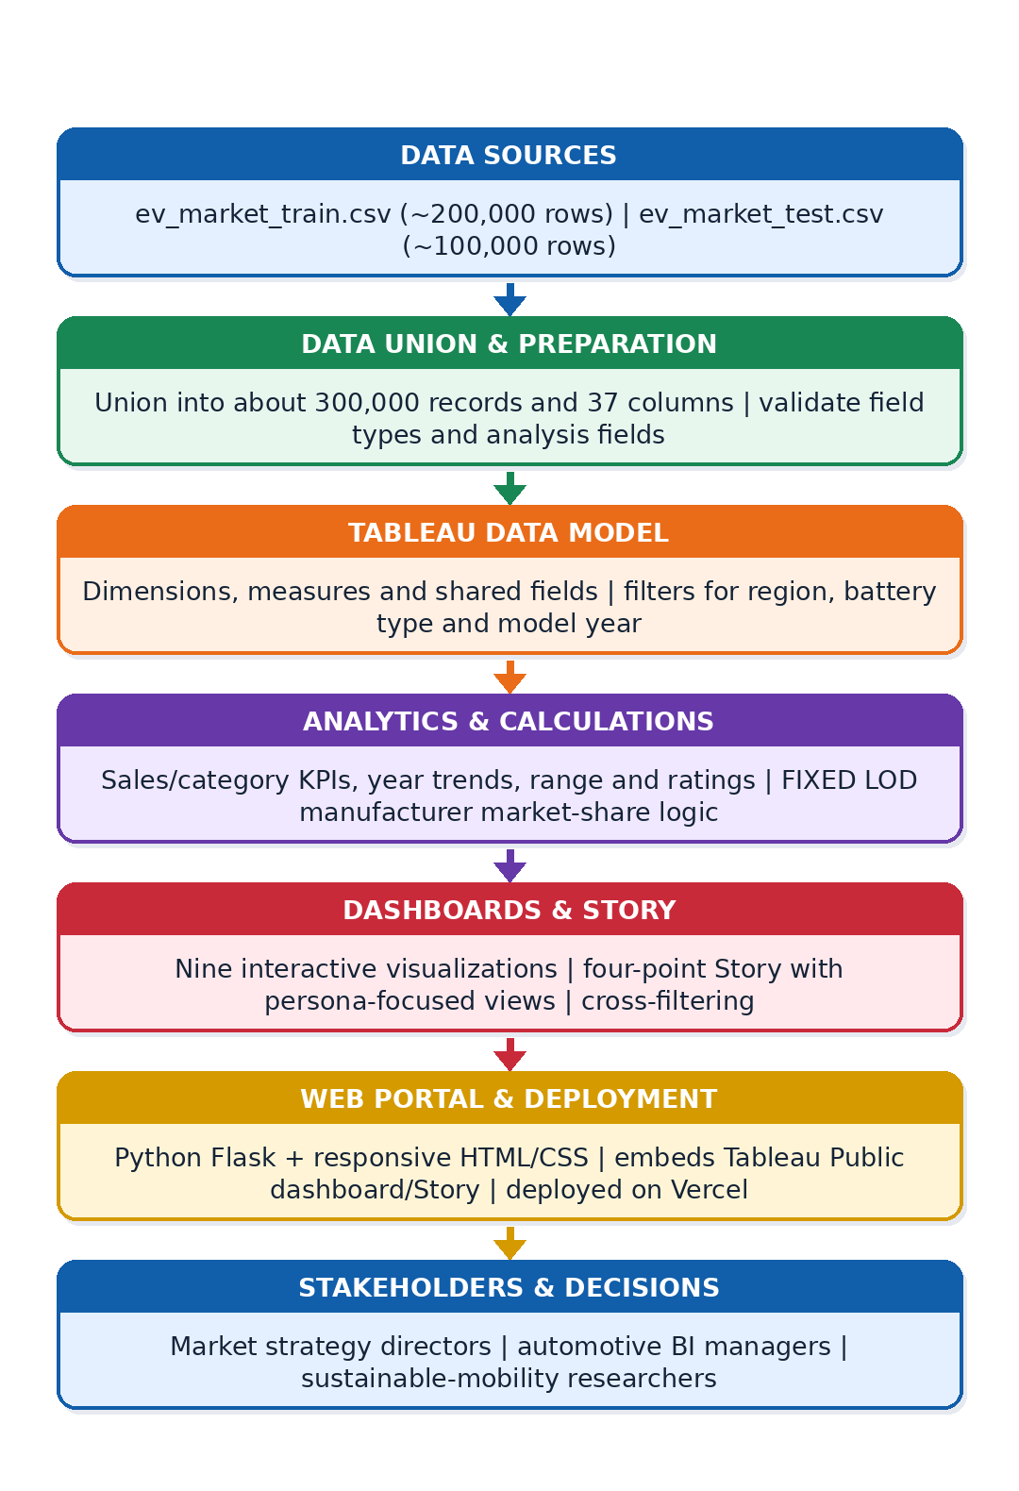

Component Description Table
Component Name | Description / Role in Architecture | Technology Used
Data sources and integration | Combines the training and test CSV sources into one analysis dataset of about 300,000 records and 37 columns. | CSV files; Tableau data connection / union
Data preparation | Organizes dimensions and measures for consistent comparisons and checks the fields selected for analysis. | Tableau data pane; calculated fields
Analytics and calculations | Supports sales, category, model-year, manufacturer, battery, range, ratings and geography analysis. FIXED LOD logic is used for manufacturer market share. | Tableau calculated fields; FIXED LOD
Interactive dashboard controls | Enables exploration by market region, battery type and model year; dashboard actions connect related visualizations. | Tableau filters and dashboard actions
Dashboards and Story | Presents nine visualizations and a four-point Story with persona-focused views for market strategy, automotive BI and sustainability research. | Tableau Public/Desktop
Web portal and deployment | Embeds the Tableau Public dashboard and Story in a responsive web application so reviewers can access the analytics in a browser. | Python Flask; HTML/CSS; Vercel
Version control and documentation | Maintains source code and project documentation for review and final submission. | Git; GitHub repository

